L-Band Satellite Tracking and Characterization System

Construction Manual

Authors:

* Charles Kente Van Horn Jr. (Team Leader) - RF and Microwave Engineering (EE)
* Samuel Walker Taliaferro VIII Velasquez - Machine Learning (CPE)
* Justin Ward Daigle - Communications (EE)
* Ethan Christopher Duval - Networking and Cyber Security (CPE)
* Jared Jamison - Controls Robotics and Autonomy

Date: 11/30/2023

Table of Contents:

**Rotator Assembly 2**

**Power System Assembly 5**

**Antenna Assembly 8**

**Control Circuit Assembly 11**

**Enclosure Assembly 15**

**System Costs 16**

# Rotator Assembly

Necessary tools - Assorted drill bits, pvc glue, wire strippers, ratchet set, wire soldering set.

Gather the following components:

* 2x ¼ in-20 x 3-½ inch metal screws
* 4x ¼ in-20 x 1-½ inch metal screws
* 6x ¼ inch metal washers
* 2x ¼ inch metal bolts
* 2x metal Yaesu mast clamps
* 1x Yaesu G-5500DC dual Azimuth and Elevation rotator
  + For assembly of the rotator, cabling for the rotator motors, as well as integration testing to ensure functionality of the motors with the rotator control box, please refer to the Yaesu G-5500DC Instruction Manual.
* 1x ¼ inch-20 x 1-½ inch plastic screws
* 4x ¼ inch plastic washers
* 1x ¼ inch plastic bolts
* 2x Metal Yaesu U-Bolts (included with G-5500DC)
* 1x RFMAX Heavy Duty Yagi Tripod

Steps:

1. Using a Torque wrench, connect the rotator masting clamps to the bottom of the rotator. Use the 4x ¼ in-20 x 1-½ inch metal screws and 4 associated washers and bolts to secure the masting clamp to the rotator.

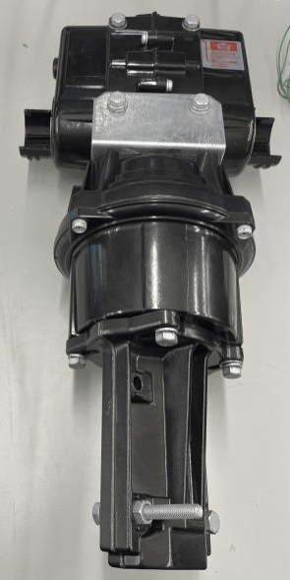

1. Slide the rotator onto the tripod, and ensure that the masting clamps are positioned around the tripod.
2. Using the 2x ¼ in-20 x 3-½ inch metal screws and associated washers / bolts, secure the rotator to the tripod by screwing the masting clamps together (screw this into the bottom hole of the masting clamps).

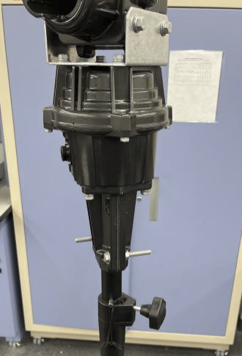

1. The next step of the process is securing the antenna on the rotator PVC pipe. To do so:
   1. Slide the mount PVC into the largest hole of the Antenna. Line the arrow on the mount PVC to the arrow on the antenna. They should be facing each other.
   2. Line up the screw hole of the rotator with the screw hole of the attached PVC pipe, and secure this by feeding the 1x ¼ inch-20 x 1-½ inch plastic screw into the associated screw hole. For the rotator PVC pipe, this hole is located at the end of the smaller attached portion of PVC. The plastic screw is required to fit through both the hole of the antenna as well as the hole of the rotator PVC, so that when attaching the PVC pipes, the arrow on the antenna PVC is facing the arrow on the mount PVC. Ensure that the plastic screw has the larger washer and 2x ¼ inch plastic washers attached before using the screw.
   3. Secure the plastic screw using 2x ¼ inch plastic washers and 2x ¼ inch plastic bolts.
2. Once the antenna has been secured, slide the PVC pipe through the rotator elevation motor, and secure the PVC pipe at the correct angle using the 2x Metal Yaesu U-Bolts. Use the associated markers to ensure proper height. A photo of this is shown below:

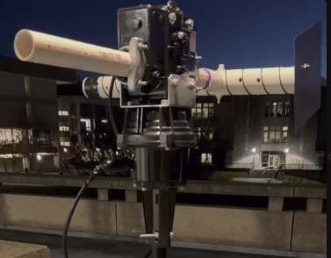

# 

# 

# 

# 

# Power System Assembly

* Using a ten gauge connecting device( ring crimp, typically with a yellow wrapper), connect the red colored bolt to one end of the fuse.

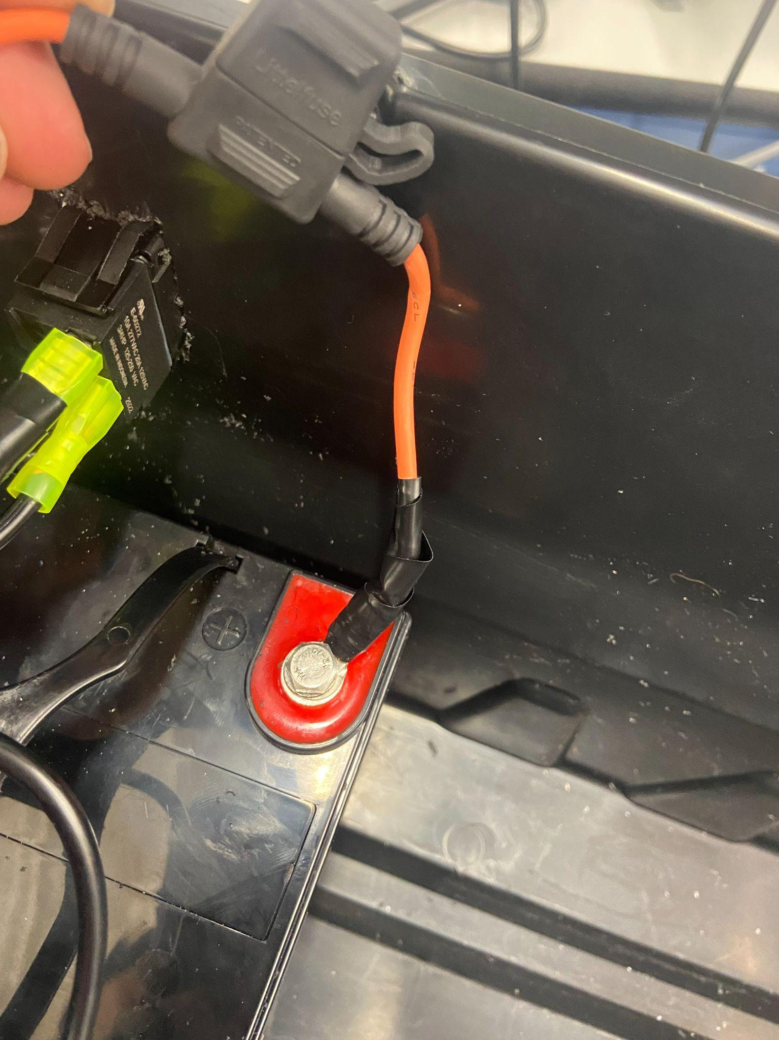

* Take the inverter out of its box, and cut the wires to the plug, leaving a little extra on the plug. Take the car plug apart, and find which wire is connected to the peg at the bottom. There should be some form of marking on this wire(on the test model, a white stripe.)
* Take the corresponding wire from the inverter and connect it to the other end of the fuse box. On the test model this was done with blue colored crimps. Wrap both connections in electrical tape. The fuse box should now have both wires connected.

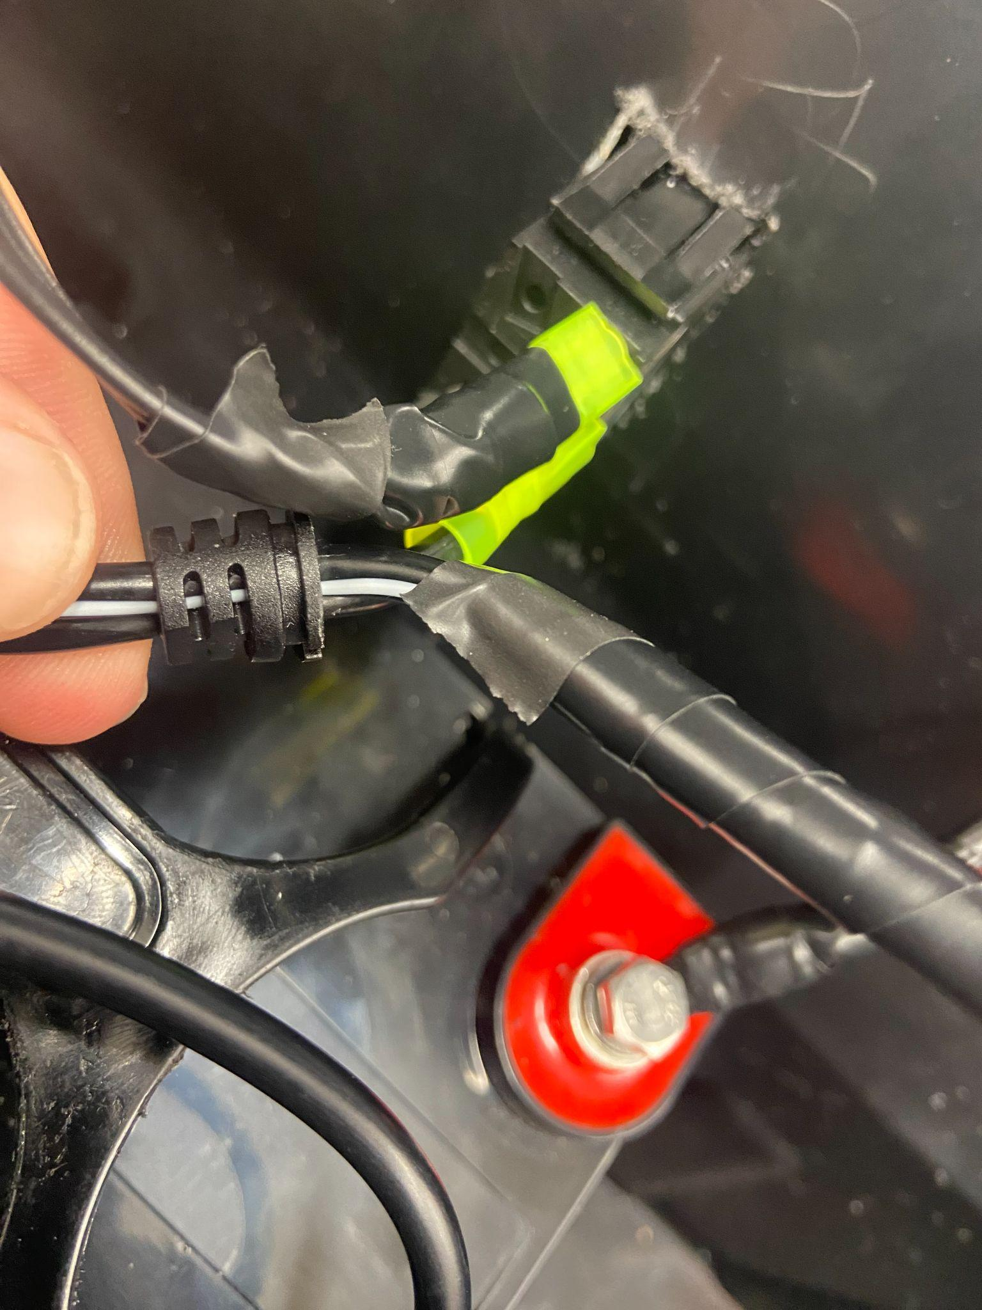

* Take the blue wire from the emergency stop switch and crimp it directly to the unused write from the inverter.
* Connect the other two wires from the emergency stop switch, and twist the two ends together. Take this connection and crimp it with a yellow ring crimp. Connect this to the black terminal of the battery.

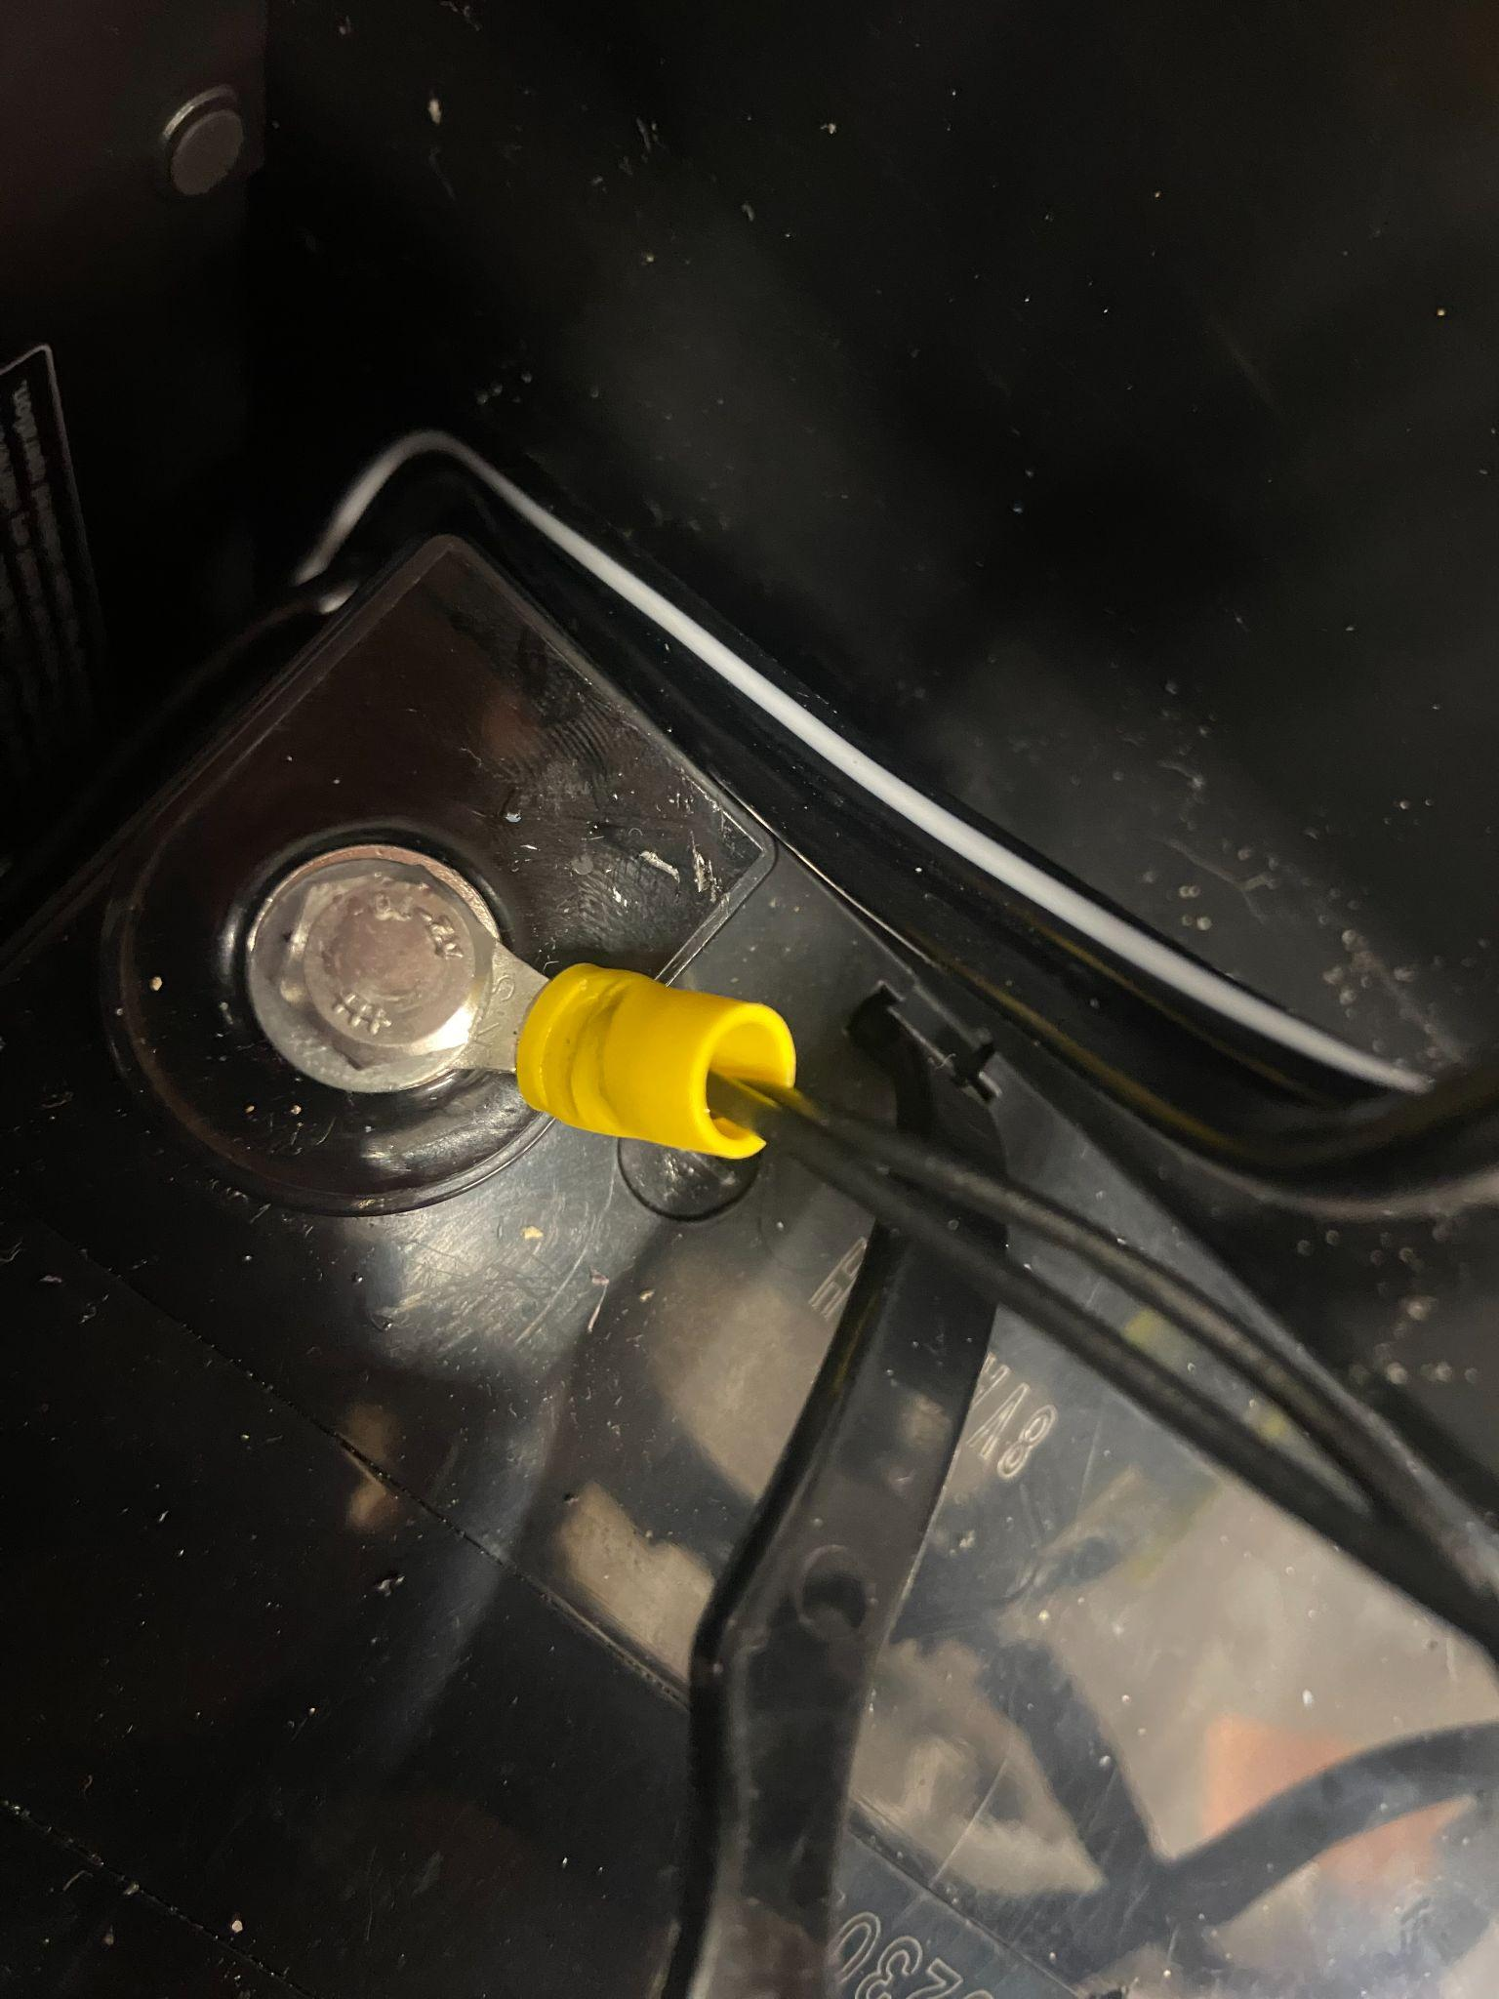

* The wiring of the power system is now complete. Before continuing, ensure that all connections are properly secured, and wrapped with electrical tape.
* Plug the rotator control box(the silver box) into one of the ports on the inverter. Wrap the remaining cord, as it will not be needed.
* Take the usb cord for the computer power, and plug it into one of the USB ports on the inverter.
* Place a 15 amp mini fuse into the fuse box and turn everything on. Ensure that everything works.
* This concludes the power system assembly.

# Antenna Assembly

Gather the following materials:

* 2in ID, 2 and 3/8in OD PVC pipe, 6ft
* 14 gauge insulated solid copper wire, 50ft
* 8x8in thin copper sheet
* Panel mount SMA connector
* M4 bolts and nuts
* Duct tape
* JBWeld epoxy

The following tools will be needed to build the antenna:

* Hand drill and assortment of drill bits.
* Hacksaw or bandsaw
* Soldering iron
* Pliers
* Bench vice
* Wire strippers

*Antenna Mast Assembly*

1. Cut PVC pipe to a length of 3ft using a band saw, hacksaw, or other appropriate tool.

2. Starting from 1in from the end of the PVC pipe, using a marker, make marks every 48.3mm, or 1.9in. These will guide the spacing of the helix windings.

3. Drill a small hole over the first winding mark, just larger than the diameter of the wire. This will help create tension as you wind the antenna.

4. Feed a small amount of wire through the hole and bend it so that it can be put under tension. Then, Using a solid surface as a brace, tightly wind the wire around the PVC pipe so that each turn of the wire passes over the next subsequent marking. Ensure that the spacing of the wire is as neat and uniform as possible.

5. Once the entire length of the antenna is wrapped, use duct tape to hold the wire in place, ensuring that it is wrapped tightly to the PVC.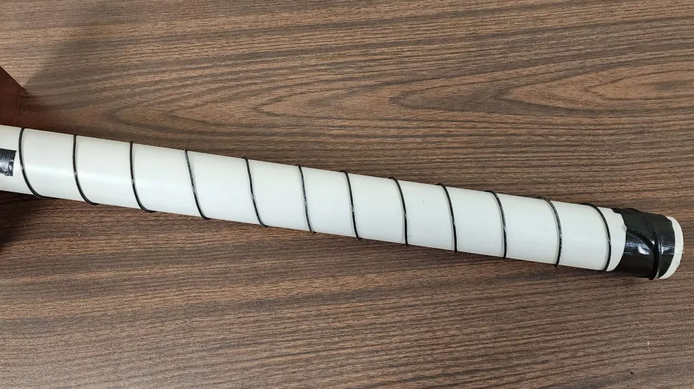

*Ground Plane Assembly*

1. The PVC pipe should be placed in the center of the 8x8in copper sheet. At any point around the circumference of the pipe, approximately 1cm away, a mark should be made. A hole should be drilled at this point large enough so that the dielectric and center pin of the panel-mount SMA connector can be slid through.

2. Once the connector is slid through, holes should be drilled in the locations of the surrounding mounting holes of the panel-mount SMA connector.

3. Once the holes are drilled, the M4 bolts and nuts are used to fasten the panel-mount SMA connector to the 8x8in copper sheet. With this, the ground plane is fully assembled.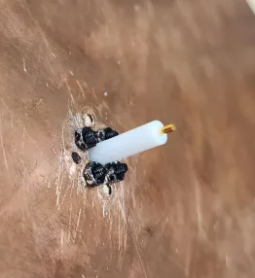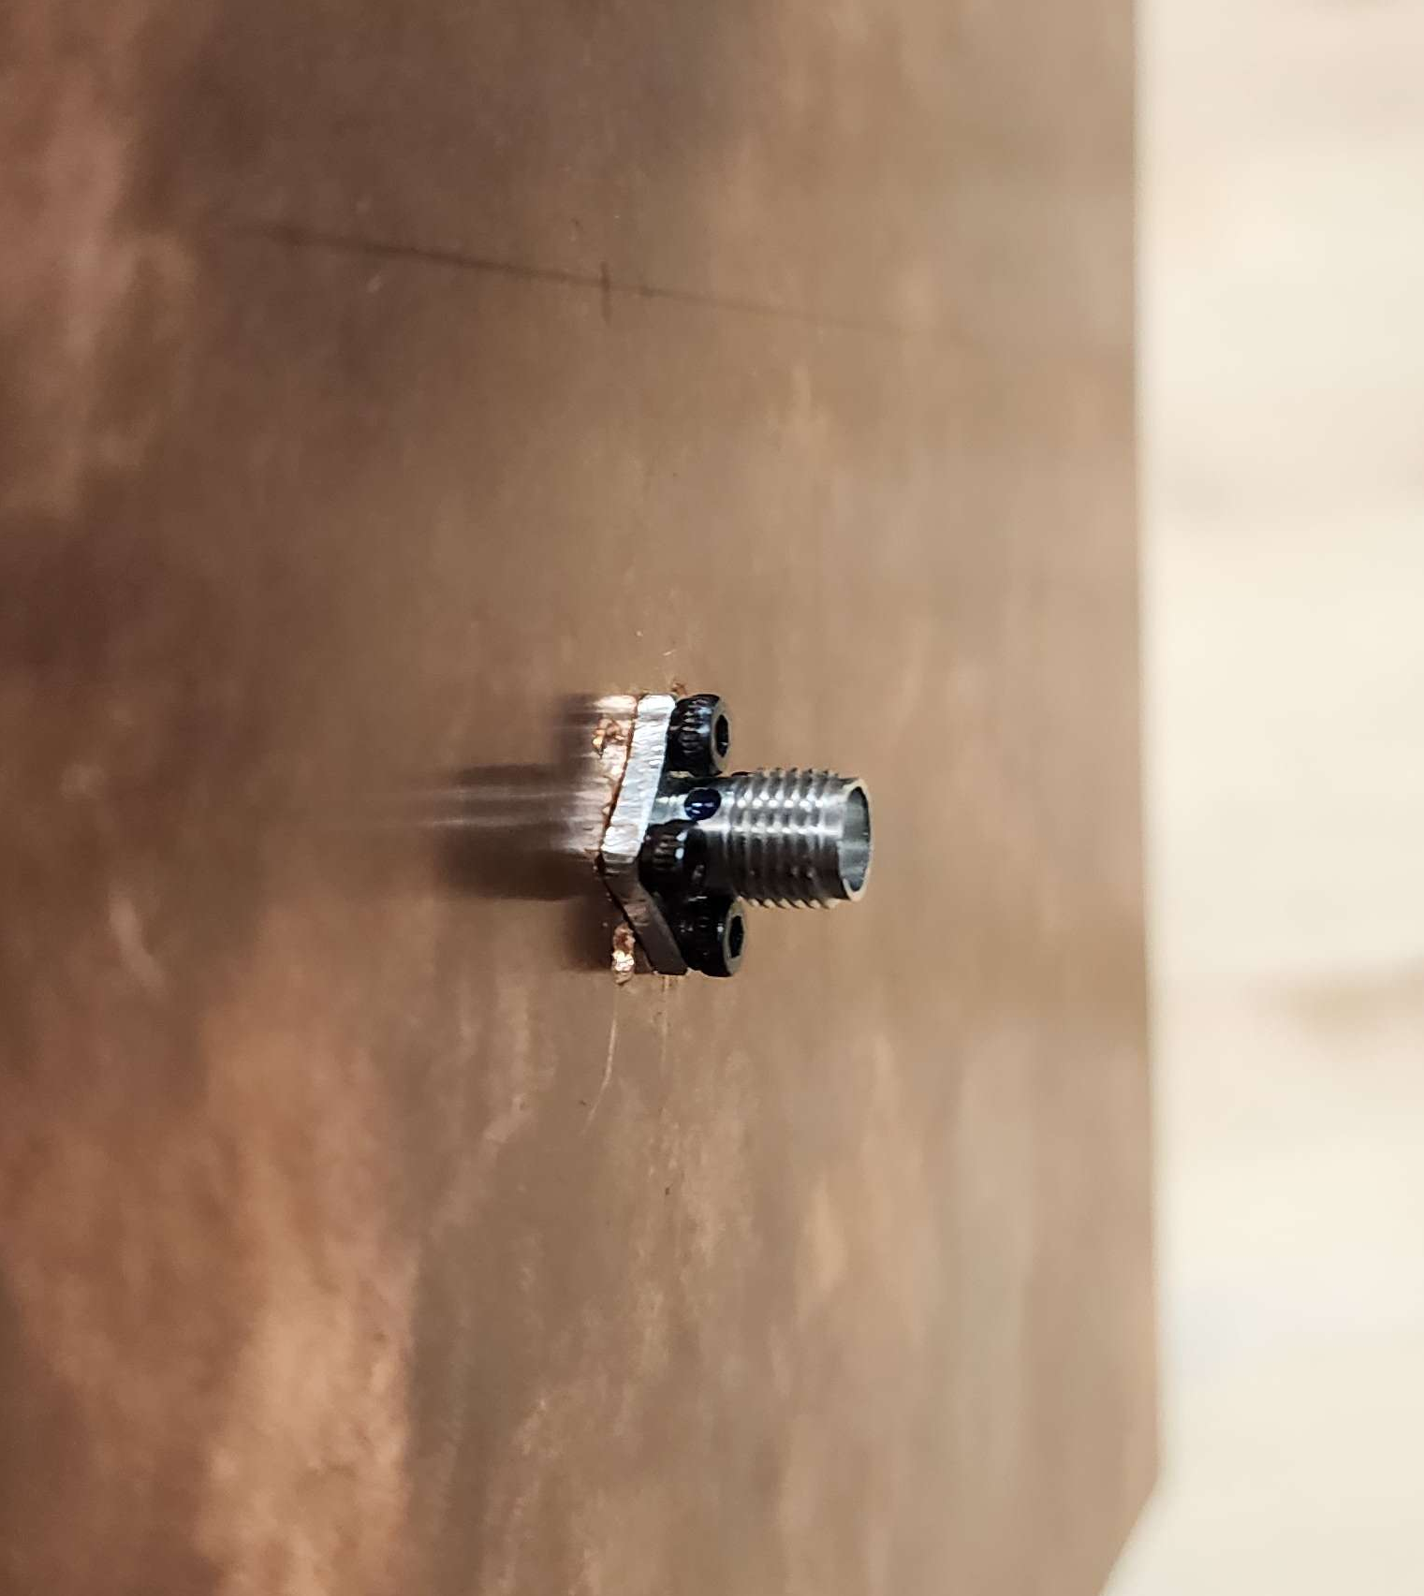

*Final Assembly*:

Now that the antenna mast and ground plane are complete, the two can be joined together to finish the antenna assembly.

1. The PVC should be once again placed in the center of the ground plane, with the panel-mount SMA connector’s threads facing the opposite direction as the mast.

2. The solid copper wire that was threaded through the hole we drilled into the PVC earlier should be pulled out, and ~2in from the end should have its insulation stripped.

3. Rotate the PVC such that the stripped portion of the antenna wire intersects with the panel-mount SMA connector’s center pin 3cm from the end.

4. Maintaining this alignment, carefully use the JBWeld epoxy to join the PVC mast to the ground plane. Epoxy should be applied between the mast and the ground plane, as well as immediately surrounding the mast, in order to create a strong bond. Let this set for at least 12 hours.

5. Once the epoxy has set, solder the stripped end of the antenna wire to the center pin of the SMA connector. It is helpful to bend the wire such that it intersects on the inside of the center pin, and is putting some outward tension on it, for a strong connection. It is also recommended to spend a good amount of time heating the antenna wire, before you apply heat to the SMA connector’s center pin, as the thick antenna wire takes much more time to heat.

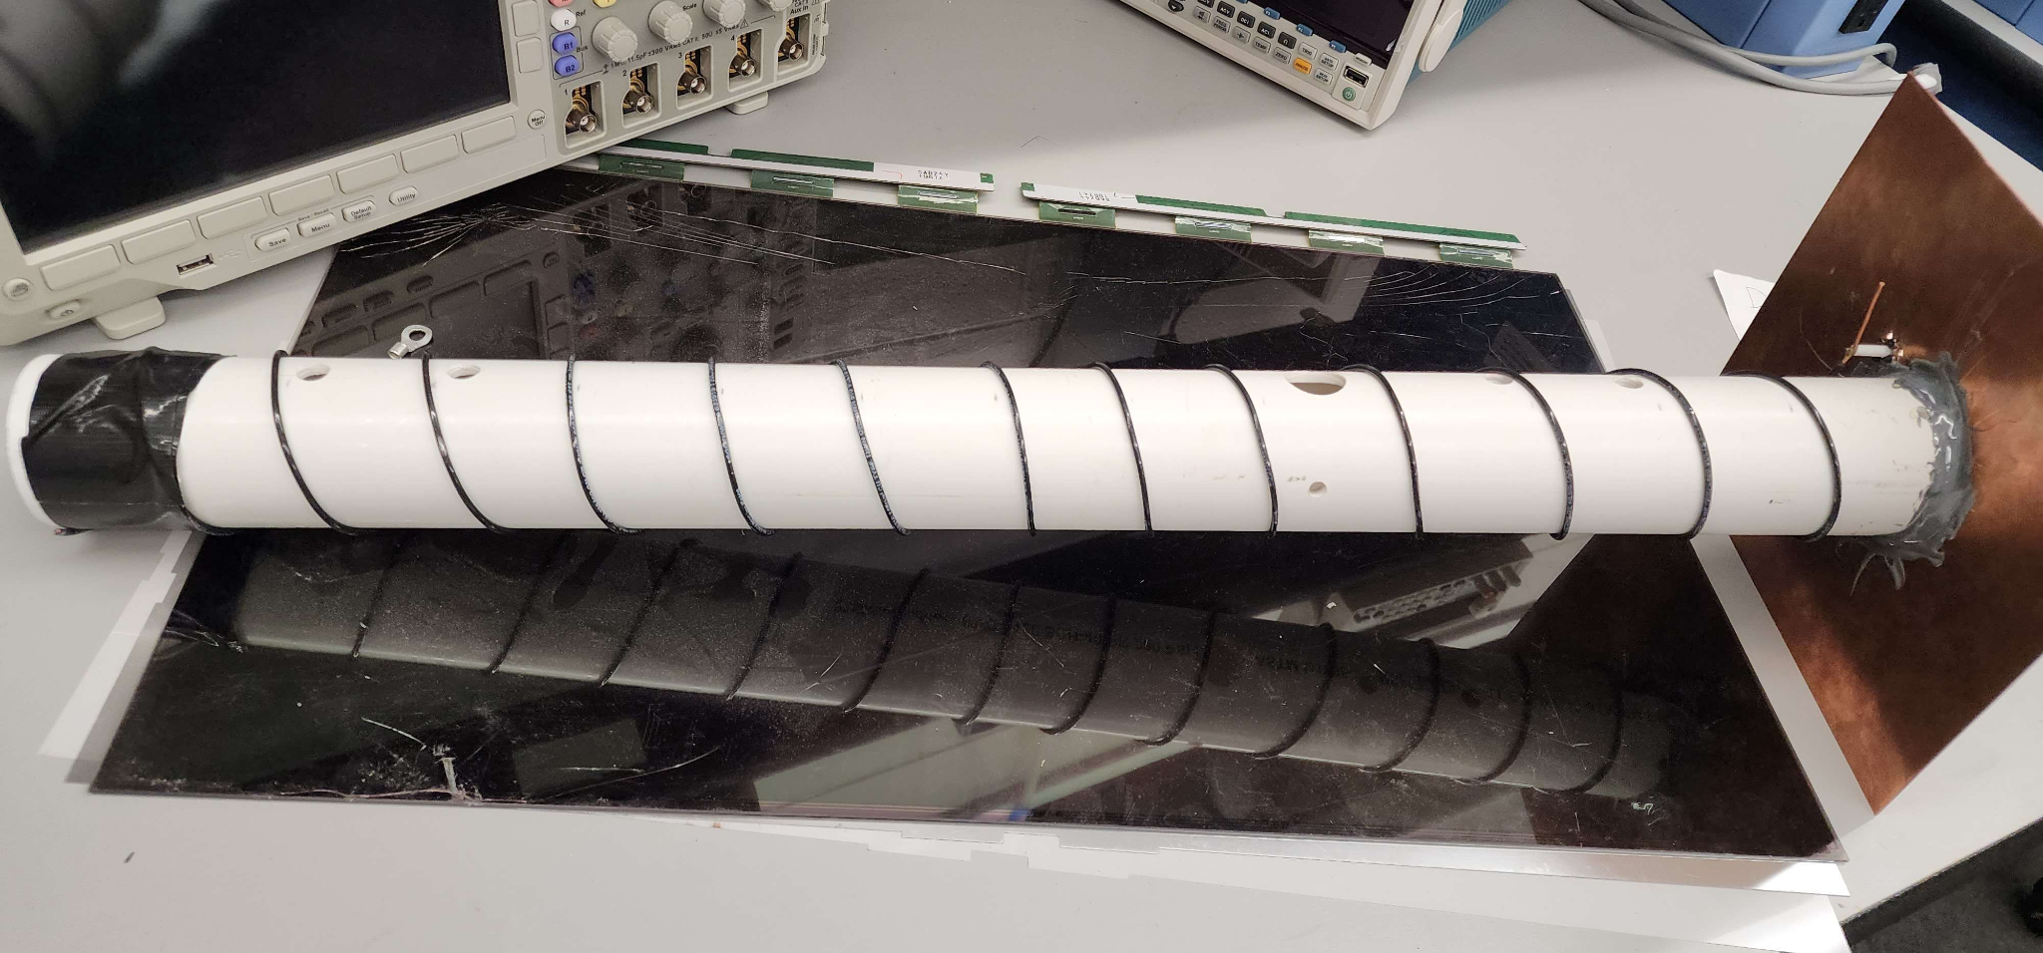

# Control Circuit Assembly

Gather the following materials:

* 1x feed-through breadboard (A normal breadboard works as well, but this design uses a feed-through breadboard for added security).
* 1x Adafruit Feather M0
* 4x 220 Ohm Resistors
* 8x 1K Ohm Resistor
* 4x 390 Ohm Resistors
* 2x ILD2 Optocouplers
* 4x 100k Ohm Resistors
* 4x 0.1 uF Capacitors
* 4x LED
* 4x 2n2222 NPN Transistors
* Colored Wire.

1. Connect the Feather M0 to the feed-through breadboard. For this design, the pins used on the Feather M0 are A0, A1, Pins 10-13, ground, and the 3.3V power.
2. If using a feed-through breadboard, create a solder voltage and ground rail to the 40th line on the breadboard. A photo of these lines is shown below:

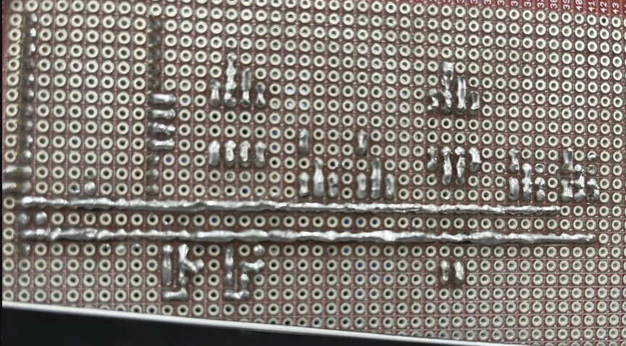

1. Connect the ILD2 Optocouplers to the circuit board, and wire the circuit as shown in the diagrams below. The first diagram shows the physical design of the circuit, as used, and the second diagram shows the simulated model.

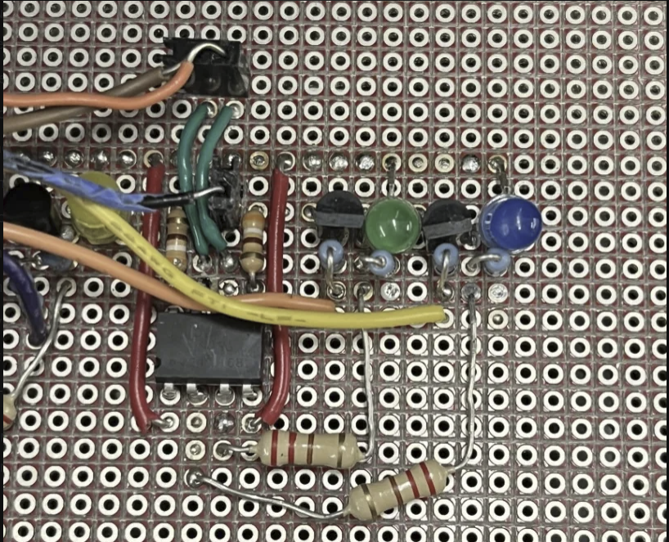

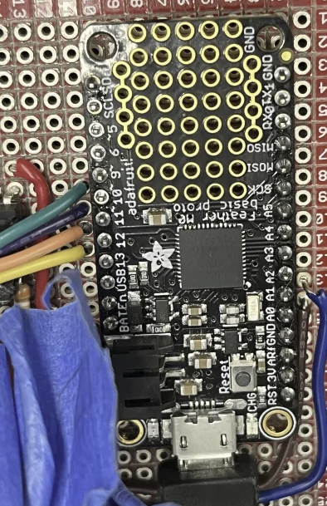

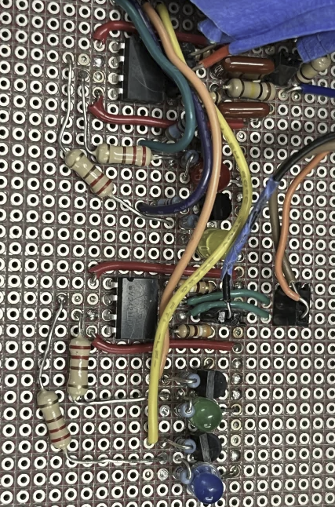

1. This circuit is a series of four separate repeated circuit designs repeated for each of the four rotational directions. This circuit is configured as a common emitter circuit, and the sent commands are from the onboard computer to the rotator. The pins for A0 and A1 are used for status updates from the rotator to the onboard computer, and were configured uniquely from the circuits for cardinal direction. The simulated photo for the circuit, as well as the pins for the Feather M0 are shown below:

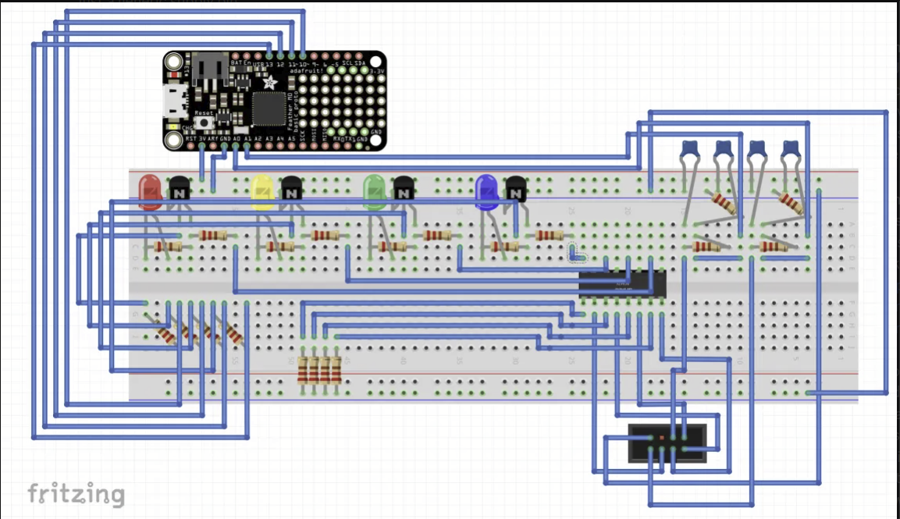

* 1. Rotational Pins
     1. Pin up 10
     2. Down 11
     3. Left 12
     4. Right 13
  2. Status - Calibration Pins
     1. Az = A0
     2. El = A1

1. Construction of the Rotational Pin Circuit:

Disclaimer: The pins for the Yaesu rotator are listed on the Yaesu instruction manual, these pins were used for development of this project. For the ILD2 optocouplers, each individual optocoupler is used for two separate rotational pin circuits, and thus development of a second circuit can be done using the pin guide in the photo below:

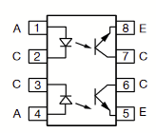

* 1. Connect the directional pin from the Feather M0 into pin 6 of the ILD2.
  2. Use a 390 Ohm resistor to connect pin 8 of the ILD2 to ground.
  3. Attach pin 4 of the ILD2 to the power supply of the Feather M0.
  4. Connect pin 3 of the ILD2 to a 220 Ohm resistor, which feeds into both a 1k Ohm resistor and the collector of the 2n2222 transistor.
  5. Connect the 1k Ohm resistor to the LED, which in turn should connect to the 3.3V power rail.
  6. The base of the 2n2222 transistor should connect to the directional pin from the Yaesu rotator, and the emitter should be connected to ground.

1. Construction of the Status Pin Circuit:

Disclaimer: This circuit should be repeated twice, once for each of the two pins on the Feather M0

* 1. Connect the pin from the Feather M0 to both a 0.1 uF capacitor as well as a 100k Hz resistor.
  2. Connect the 0.1 uF capacitor to ground, and connect the 100k ohm resistor to another 100k ohm resistor and a separate channel.
  3. The second 100k ohm resistor is connected to ground.
  4. The second channel of the circuit should be connected to the corresponding pin of the Yaesu rotator, as well as a 0.1 uF capacitor connected to ground.

# Enclosure Assembly

* Take the completed power assembly, and place it against one corner of the box, with the inverter being in one corner, and the battery being in front of it.
* The emergency stop button is a ⅞ bit, drill a hole somewhere near the battery to mount it so that the button is on the outside of the box. Ensure that there is slack in the wire to prevent the button from being pulled free should the battery shift during transit.
* Mount the Emergency stop button so that it is secure.
* Take the SDR, Raspberry pi, and the mount circuit and put them in the small black box in the configuration shown below. Drill five holes, one directly in front of the SDR about a half inch thick, another in front of the raspberry pi an inch thick, and another behind the SDR about a half inch thick.
* Find where the circuit control wires will stick out of the top of the box, and drill a hole large enough to tightly fit all of the control wires through.
* Find where the power cable for the rotator circuit will go through the top of the box, and drill a hole large enough for the cable to fit through.
* Run all cables and wires through the holes, minimizing the amount of cable inside of the box. Once this is done, close the lid and screw it down.
* Place the rotator box beside the battery on its side, ensuring that the two are side by side. Ensure that the controls are facing towards the open section of the box.
* Drill two holes in the back, just behind the rotator box, where the screws for the rotator control wires are.
* Feed the control wires through the box, and connect them to their respective terminals.
* Place the box with the computer, SDR, and control circuit on top of the rotator control box.
* Silicon seal all holes that were drilled in the main box(Emergency stop switch, and the two cable exit points). Sand the box around these areas to give the silicone something to adhere to.
* The enclosure is now fully assembled.

# System Costs

The spreadsheet below totals the final cost of the system components